TOWN OF BERGEN
* Established April 2, 1813 *

Phone: (585) 494-1121 * Fax: (585) 494-1372 * NYS TDD 1-800-662-1220

P.O. Box 249
10 Hunter Street
Bergen, NY 14416

Supervisor Town Clerk/Tax Collector
Donald S. Cunningham Michele M. Smith
Councilmen Justices
Brian Stone, Deputy Supervisor Joseph nenni
Ernest Haywood
Mark Anderson Robert Swapceinski

Councilwoman zoning & code enforcement officer
Belinda Grant David Mason

Superintendent of highways Assessor
mike Johnson Rhonda Saulsbury 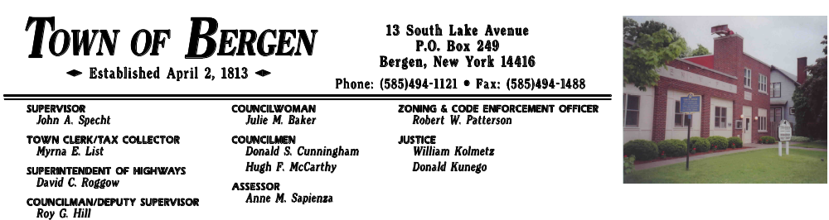 Anne M. Sapienza

June 20, 2017

LEGAL NOTICE
NOTICE OF PUBLIC HEARING
TOWN OF BERGEN

The Town of Bergen will hold a public hearing on June 27, 2017 at 7:00 pm at the Bergen Town Hall 10 Hunter St. Bergen, NY for the purpose of hearing public comments on the Town of Bergen’s community development needs, and to discuss the possible submission of one or more Community Development Block Grant (CDBG) applications for the 2017 program year. The CDBG
Program is administered by the New York State Office of Community Renewal (OCR), and will make available to eligible local governments approximately $300,000 for the 2017 program year for housing, economic development, public facilities, public infrastructure, and planning activities, with the principal purpose of benefitting low/moderate income persons. The hearing will provide further information about the CDBG program and will allow for citizen participation in the development of any proposed grant applications and/or to provide technical assistance to develop alternate proposals. Comments on the CDBG program or proposed project (s) will be received at this time. The hearing is being conducted pursuant to Section 570.486, Subpart I of the CFR and in compliance with the requirements of the Housing and Community Development Act of 1974, as amended.

The Bergen Town Hall is accessible to persons with disabilities. If special accommodations are needed for persons with disabilities, those with hearing impairments, or those in need o translation from English, those individuals should contact Town Clerk Michele Smith at 585-494-1121 x21, at least one week in advance of the hearing date to allow for necessary arrangements. Written comments may also be submitted to Supervisor Donald Cunningham P.O. Box 249 Bergen, NY 14416 until June 27, 2017.

By Order of the Bergen Town Board
Michele M. Smith, Town Clerk

