TOWN OF BERGEN
* Established April 2, 1813 *

Phone: (585) 494-1121 * Fax: (585) 494-1372 * NYS TDD 1-800-662-1220

P.O. Box 249
10 Hunter Street
Bergen, NY 14416
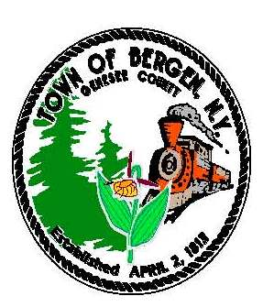
Supervisor Town Clerk/Tax Collector
Donald S. Cunningham Michele M. Smith
Councilmen Justices
Brian Stone, Deputy Supervisor Joseph nenni
Ernest Haywood
Mark Anderson Robert Swapceinski

Councilwoman zoning & code enforcement officer
Belinda Grant David Mason

Superintendent of highways Assessor
mike Johnson Rhonda Saulsbury 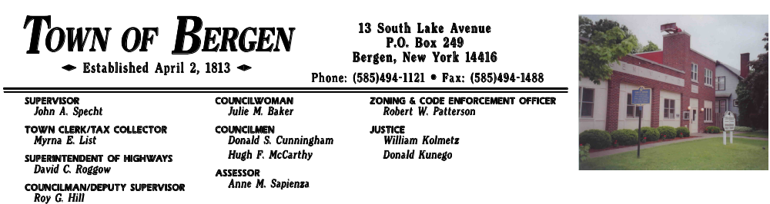 Anne M. Sapienza

Town of Bergen Residents
Brush pick-up for windstorm damage

after the windstorm the Town of Bergen authorized a “town wide brush pick-up” starting on the North side of town on April 10th and continuing until finished.

the following rules are to be observed:
- We will only make one (1) trip per road
- Put all brush and logs parallel to the road
- All logs no longer that Ten(10)^{ft} in length and stacked separately
- all Debris must be roadside no later than Monday April 10th

residents or their contractor may dump at the village sewer plant prior to this date, as long as prior approval has been given. Please call the highway dept. at 494-1362 for approval. Please remember to respect and obey the signs at the sewer plant. Thank you.

Mike Johnson, Superintendent of Highways

