TOWN OF BERGEN
* Established April 2, 1813 *

Phone: (585) 494-1121 * Fax: (585) 494-1372 * NYS TDD 1-800-662-1220

P.O. Box 249
10 Hunter Street
Bergen, NY 14416
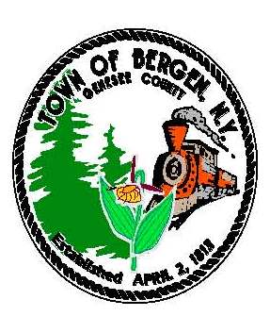
Supervisor Town Clerk/Tax Collector
Donald S. Cunningham Michele M. Smith
Councilmen Justices
Brian Stone, Deputy Supervisor Joseph nenni
Ernest Haywood Robert Swapceinski
Daniel VanVAlkernburg
Councilwoman zoning & code enforcement officer
Belinda Grant David Mason

Superintendent of highways Assessor
mike Johnson Rhonda Saulsbury 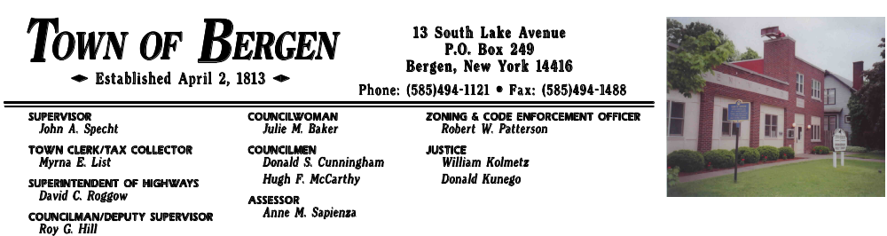 Anne M. Sapienza

July 28, 2015

Notice to Bidders

The Town of Bergen will receive sealed bids for Refuse and Garbage transportation and subsequent disposal of recyclable and non- recyclable refuse and garbage collected at the Town of Bergen Transfer site on Route 262. Bids are requested for a twenty-four month contract commencing 9/1/15 and extending through 8/31/17. Bids will be received by the Town Clerk at the Bergen Town Hall 10 Hunter Street, Bergen, New York 14416 until 2:30 PM on the 21rd day of August 2015, at which time all bids will be publicly opened and read aloud. Detailed specifications may be obtained from the Town Clerk during normal business hours.

Michele M. Smith,
Bergen Town Clerk

